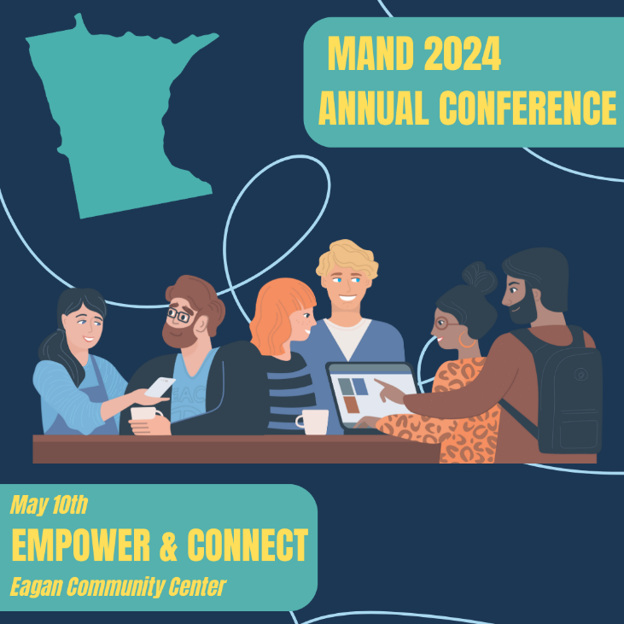
AGENDA AT A GLANCE
Overall Annual Conference Evaluation

7:15 - 7:50 AM | Registration & Networking  Continental Breakfast  Exhibits
7:50 - 8:00 AM | President & Planning Committee’s Welcome
8:00 - 9:00 AM | Keynote Speaker  A.I. Unleashed: Shaping Dietetics Practice in the Digital Age  Drew Hemler, MSc, RD, CDN, FAND  Evaluation
9:00 - 9:30 AM | Break/Exhibits/Posters
9:30 – 10:30 AM | Breakout Sessions  Leadership: From Self-Care to Self-Empowerment: A New Outlook on Dietitian Job Satisfaction and Well-Being  Lauren Fleck, MS, RD  Evaluation  Clinical: Functional Medicine and Applications for Private Practice & Clinical Care  Jessica Carter, MS, RDN, LD, CDCES, E-RYT200hr, PhD Student of Integration & Functional Nutrition  Evaluation  Nutrition Professionals in Practice: Step-By-Step: How to Build an Authentic Brand That Converts  Ashley Moyna Schwickert, MS, RD  Evaluation
10:40-11:40 AM | Breakout Sessions  Leadership: More Than Meets the Eye: The Importance of Utilizing the Social Determinants of Health in Dietetics  Emily Heying, PhD, RD, LD  Evaluation  Clinical: Culturally Competent Menu Development  Leah Hebert, Executive Director, Open Arms  Evaluation  Nutrition Professionals in Practice: Tracking Macros: How to Use a Flexible Dieting Approach to Facilitate Body Change  Emily Field, MPH, RD, CPT (NASM)  Evaluation
11:40 AM – 12:30 PM | Lunch  Business Meeting  Awards
12:30 - 1 PM | Break/Exhibits/Posters
1:00 - 2:00 PM | Breakout Sessions  Leadership: Cultural Compass: Harnessing the Power of Your Culture in a Rapidly Changing World  Eric Pratum, MBA, MA  Evaluation  Clinical: Tube Feed or Not To Tube Feed: Ethics Beyond The Consult Question  Nina Curvis, MS, RD, LD, CNSC, Ryan Nelson, PhD, HEC-C  Evaluation  Nutrition Professionals in Practice: How We Learn What To Eat And Why  Jess Reiners, RD, LD, MS & Hilmar Wagner, MPH, RDN, CD, LN  Evaluation
2:00 - 3:00 PM | Breakout Sessions  Clinical: Fueling Mental Health Through the Power of Nutrition  Lauren Fleck, MS, RD  Evaluation  Nutrition Professionals in Practice: Empowering Nutrition Professionals to Bring Value to Your Organization and Connecting with RDN’s Who Are Billing for MNT  Zeinab Alol, MSc, RD, CLC, CFI, LND, Donna Gjesvold, RDN, LD, CCTD, Stacey Hoffman, RD, LD, Louann Kaupa, RD, LD (Moderator), Priyanka Sagar, M.Sc., RDN, LD  Evaluation
3:00 -3:30 PM | Break/Exhibits/Posters
3:30-4:30 PM | Keynote Speaker  Empowering RDNs to Achieve Professional Goals: A Panel Discussion on Terminal Degrees and Certifications  Katie Galloway, MBA, RD, LD, IBCLC, Lindsay Heidelberger, PhD, RDN, LDN, Melissa Jaeger, RD, LD (Moderator), Leah Qubty, DCN, MS, RDN, LDN, FAND, Amanda Rau, CDE, Toni Swanson RDN, CSG, LD  Evaluation
4:30-6:00 PM | Happy Hour

Up to 6 CPEUs for Conference Educational Sessions
CPEUs for Posters (1.75)
CDR no longer provides CPEUs for Exhibitors

