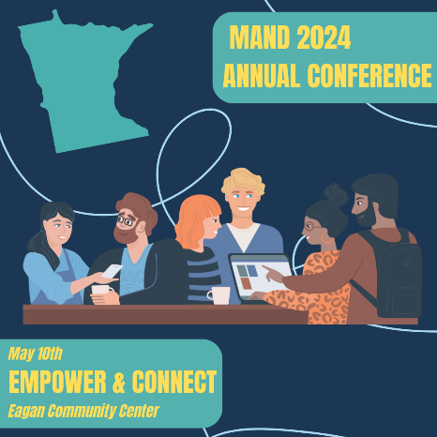

MAND 2024 ANNUAL CONFERENCE
VENDOR OPPORTUNITIES
May 10, 2024 ● Eagan Community Center

SPONSORSHIP OPPORTUNITIES
- Lunch Sponsor (1 available) $6,000
- Happy Hour Sponsor (1 available) $4,000
- Breakfast Sponsor (1 available) $3,000
- Break Sponsor (1 available) $1,500

If you are interested in an add-on opportunity to sponsor a speaker (honorarium/travel) or a more customized sponsorship opportunity, let’s talk!

EXHIBITING OPPORTUNITIES
- Entire Conference $300 For Profit/$250 Nonprofit
- Additional Attendee Meal Ticket $45

PRINTED PROGRAM ADVERTISING
- Full Page $300
- ½ Page $150
- ¼ Page $ 75

SPONSOR/EXHIBITOR RECOGNITION

CONTRIBUTION  LEVEL | EXHIBIT SPACE | MEAL TICKETS | MAIN STAGE INTRO | PROGRAM ADS | OTHER PRINTED MATERIALS/SOCIAL MEDIA
$6,000 | Yes | 4 | Yes | Full page | Yes
$4,000 | Yes | 3 | Yes | ½ page | Yes
$3,000 | Yes | 2 | Yes | ½ page | Yes
$1,500 | Yes | 2 | Yes | ¼ page | Yes
Exhibitor 1 Day | Yes | 1 |  |  | Yes
In-Kind Donations |  |  |  |  | Yes

QUESTIONS? Contact Sara Sternberger, Executive Director at mand@eatrightmn.org

