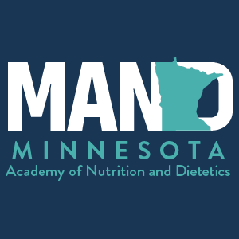

MINNESOTA ACADEMY OF NUTRITION AND DIETETICS (MAND)
CERTIFICATE OF PARTICIPATION IN A BOARD/LEADERSHIP POSITION
CPEU: Up to 15 hours over 5-Year Timeframe

NAME:

ACADEMY NUMBER:

POSITION:

TIMEFRAME:

Toni Swanson Sara Sternberger
Toni Swanson Sara Sternberger
MAND President 2022-23 MAND Executive Director 2020-2024

