Game Night Basket: Snow Happy Puzzle, Sorry, popcorn, Trivia Pursuit Coasters, Candy Land, Uno, Phase 10, and Scramble Squares Frog Puzzle.
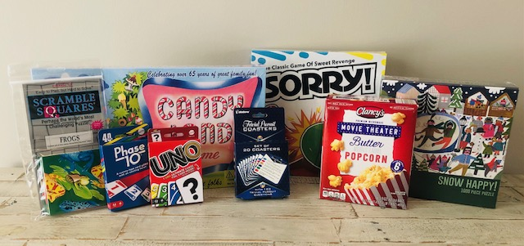

Pamper Basket: Bottle of wine, various lotion/hand soap set, Dr. Teal's Relax and Relief gift set, wine opener, cosmetic bag, candle, bar of soap, hand masks, face masks, luffa, chocolates, and tea.
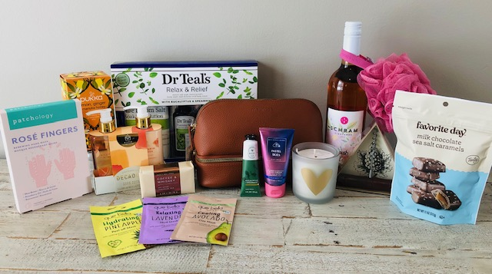

Grillin’ Basket: Parini- chicken roaster, reversible griddle, BBQ grilling basket, and cedar planks, whiskey stones, hand towel, and water bottle.
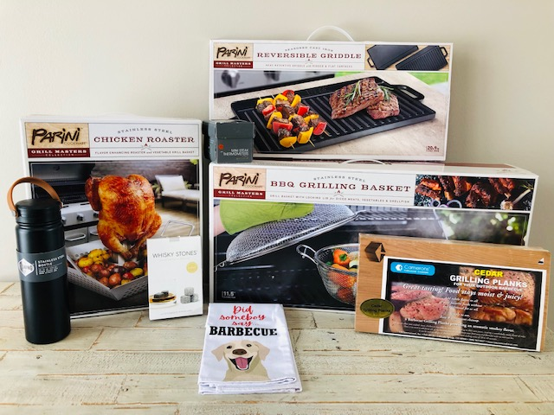
For the Kiddos Basket: Zebra stuffed animal, book, 3 reusable fruit pouches, elephant bookends, Go Fish card game, Rainbow Chalk set, Crayons, and Encanto Coloring Book.
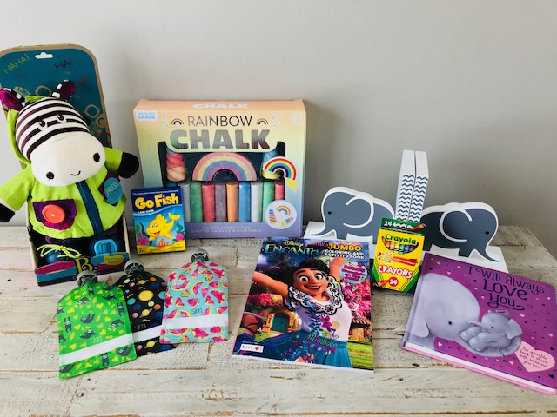

Cookin’ in the Kitchen: Parini Sandwich Maker, Bamboo Cutting Boards set, Cheese knife set, apron, pot holders, oven mitts, Ello Reusable Bags, 3 pepper shaped bowls.
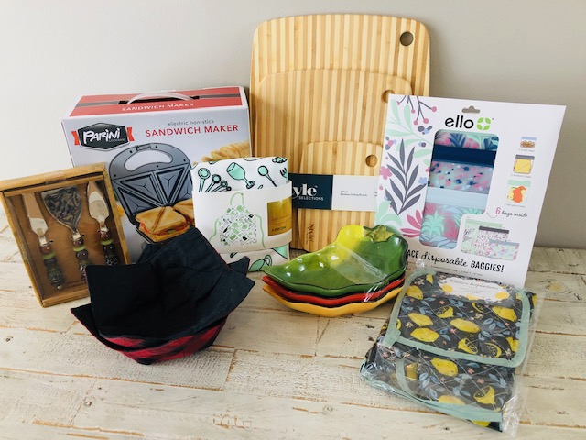

You Betcha Basket (all items from Minnesota BIPOC-owned businesses): Vikings pot holders, Mckenzie Place Mild Pepper Jelly and wild rice from Bemidji MN, Stillwater olive oil, 2 Free Free Wine or Beer Sampling from Carlos Creek Winery, and a Bipoc Makers of MN box containing: Legendary Mr. B's BBQ Sauce, Hacienda San Jose Chocolate Bar, ReMix Popcorn and Delights, Zambezi Kitchen Smokey Savage Rub and Seasoning, Zambezi Biltong Moto Moto Dried Beef Snack, and K-Mama Korean Hot Sauce.
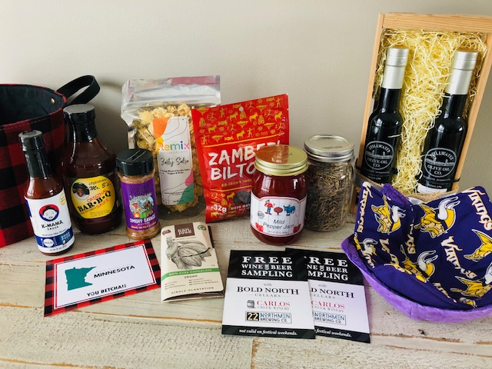

Undeniably Dairy (donated by Midwest Dairy): Featuring a great combination of fun and useful kitchen tools and attire.
