MAND 2022-23 STUDENT BOARD

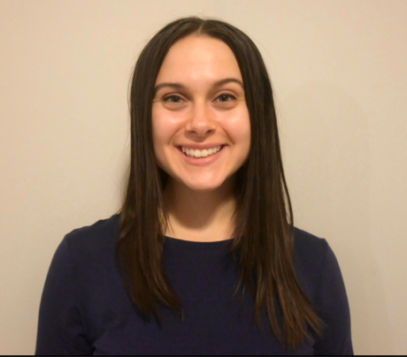
Grace Atchison
"I am a fourth year nutrition student at the University of Minnesota-Twin Cities. I am in the 4+1 Integrated Master’s program, so will complete my master’s here as well! I hope to become a pediatric dietitian with the ultimate goal of working in the NICU. I am originally from Kansas City, Missouri, but moved to Minnesota for college. When I’m not in class or working, you can find me dancing with my tap group, trying out a new coffee shop, or going to a Minnesota United game.”

"I am excited to join the MAND Student Board because it will be a great opportunity to get more involved with MAND and help spread my love of nutrition to other students throughout Minnesota! MAND provides so many opportunities for students to learn about the profession, so I cannot wait to immerse myself more in the organization.”

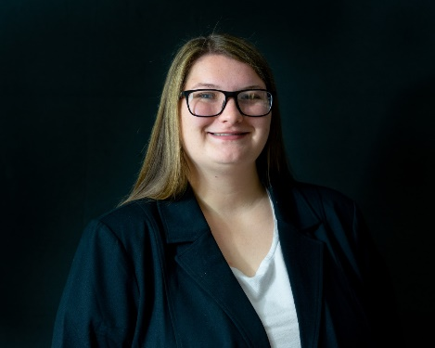
Maddalyn Bates
“I am a undergraduate senior this semester, I will be graduating this December! I am also dual-enrolled in my Master's program at UW-Stout. I joined the Student Board to try something new!”

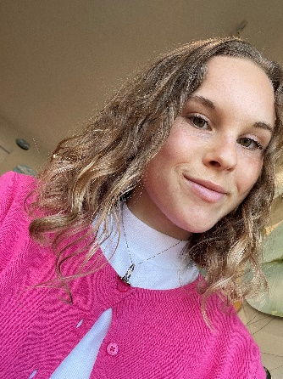
Payton Dosan
“I am a junior Dietetics student at Minnesota State University, Mankato and am so excited to be learning about the field I have always been passionate about. I am a foodie at heart and love to learn about the ins and outs of food and nutrition, as well as enjoy the science behind what we eat, how we eat, and how to cook. I dream of becoming a RDN and obtaining my own private practice, focusing on integrative health and nutrition. Besides food and nutrition, I love to be outdoors, play sports, read, and spend time with others, especially my family.”

“I am very passionate about health, wellness, nutrition, and the environment. I am excited to join MAND because I will have an opportunity to share my voice and discuss problems, solutions, information, and science with like-minded people who share my passions. I am eager to make an impact on people through education, policy, and community, and am excited to have a place to put that into action.”

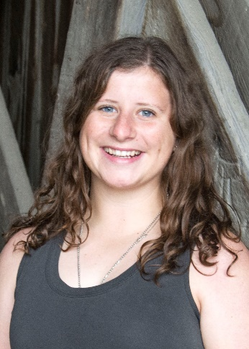
Allison Keller
“I am a Senior at UW-Stout pursuing a B.S. in Dietetics. I will graduate this spring of 2023. I currently serve as the President of the Stout Student Dietetic Association at UW-Stout. I am very interested in mother and child nutrition.”

“I am excited to join the MAND Student Board because I really want to have a voice in what we are learning from MAND and how to benefit other students. I currently serve as the president of the dietetics club on campus and I love creating opportunities for other dietetic students to grow in knowledge and professionalism. I am also really excited to network and meet other dietetic students across the state.”

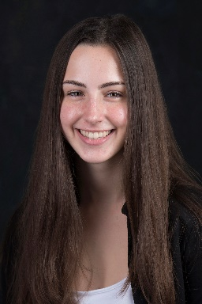
Chloe Kom
“I am a dietetics graduate student at UW-Stout (online). I live in Minnesota and work as a diet tech at a hospital. I became interested in the field for multiple reasons - I loved to watch cooking shows as a kid, have always been interested in food labels, and learned a lot about food safety and allergies through a job at a restaurant. I like to try new recipes, take walks, and run for fun.”

“I am eager to connect with other students across different dietetics programs! Collaborating with people who have different experiences and perspectives is exciting and helps us all learn. I am looking forward to learning more about and participating in MAND. I am a relatively new member.”

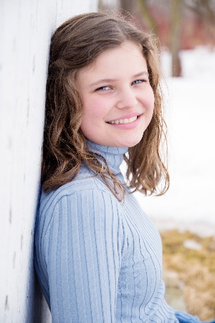
Katie Nelson
“I am a senior dietetics student at St. Catherine University in St. Paul, Minnesota. I work as a diet technician at Allina Hospital. I really enjoy my job, so I am excited to start an internship next year, especially the clinical portion! Outside of school, I spend a lot of time reading and playing with my dog and cat.”

“I have only really interacted with the small St. Kate's dietetics community, so I am very excited to meet students from other schools! In addition to building professional relationships, I want to learn how their experiences are similar and different from mine so I can become a more well rounded practitioner. I also really enjoyed serving in 4H leadership as a kid, so I am excited to do more planning and leadership work again.”

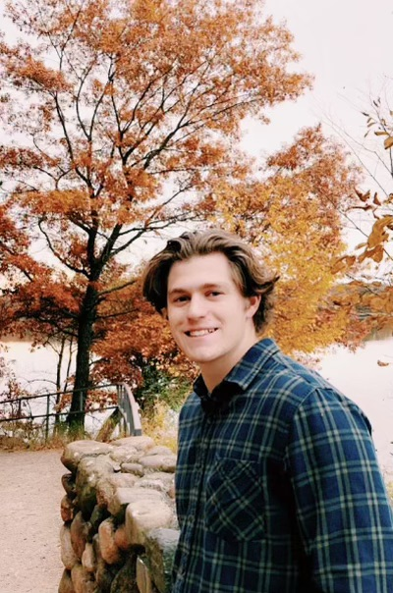
Dominic Phillips
“I am a senior studying Nutrition-Dietetics at Saint John's University in Collegeville, MN. I have found an interest in weight issues and eating disorders, as well as public health nutrition. This past summer I gained experience as a dietary technician at Methodist Hospital in Saint Lous Park, MN, and really enjoyed my time over the summer aiding patients in making informed decisions about their medical diets and assisting them in any way I could. In my free time I enjoy rock climbing, fishing, watching movies, and any outdoor activity.”

“I am very excited to meet everyone involved in the student board, and to make lasting connections in the Minnesota Nutrition/Dietetics community. I am excited to meet other Dietetic students from various Colleges and Universities, and be able to share experiences and opportunities with each other. I am also excited to make strong personal connections with other aspiring dietitians. Designing and going to nutrition related experiences is another thing I am looking forward to.”

Jannelle Schilmoeller (not pictured)

“I am currently in my second year as an online DTR student at Northland Community and Technical College in Thief River Falls, MN. I would love the opportunity to represent the DTR program and acquire a greater understanding of how to become an active member of the AND upon becoming a practicing DTR.”

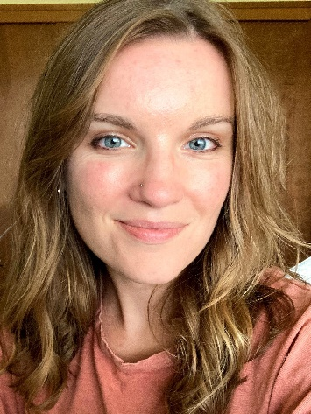
Meghan Swartz
“I live in St. Paul with my husband, 9-month-old son and our dog. We just moved here a year ago as my husband is finishing his degree at University of Minnesota. I'm currently a distance student in the University of Alabama's combined master's and DPD program. I'll graduate from the MS program in May and finish up my DPD in December 2023.”

“I'm a bit of a non-traditional student and career change -- right now I work in HR and communications for a small manufacturing company, and I previously worked in journalism, community relations and marketing. I completed my undergrad degree in journalism at Mizzou in 2015. My husband just separated from the navy last year, so the last several years included lots of moves and job changes.”

“I'm originally from the Chicago suburbs, but have also lived in San Diego and most recently Guam for 3.5 years. I've had an interest in health and nutrition since I was in high school, when I saw a holistic doctor who focused on the importance of nutrition. I was so fascinated by how different foods and ways of eating could have an effect on my health and well-being. Later on as a reporter, I loved covering food, health and the environment, but felt that I wanted to do something that was more proactive; and so decided to go back to school to become a registered dietitian. I'm still narrowing down the career path I want to pursue, but I'm very interested in outpatient nutrition counseling, sustainable food systems, maternal/infant nutrition and school nutrition. In my free time I love doing anything outdoors (especially hiking and paddle boarding), baking, or checking out new state parks with my family.”

“As a distance student, I'm so excited to get to meet more RD2Bs in person. I love planning and coordinating events and bringing people together. I previously volunteered with the HEN DPG, which was an amazing way to meet RDs and students from across the country, but now I'm really looking forward to getting more involved locally with Minnesota's nutrition community. I can't wait to get started!”

