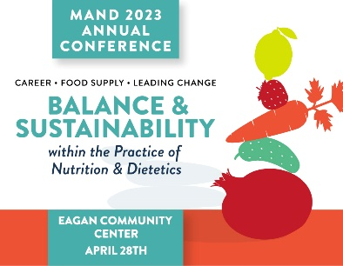

SPONSORSHIP OPPORTUNITIES
- Lunch Sponsor (1 available) $6,000
- Happy Hour Sponsor (1 available) $4,000
- Breakfast Sponsor (1 available) $3,000
- Break Sponsor (1 available) $1,500
- Speaker Sponsor* $500

*MAND appreciates its sponsors but also acknowledges that sponsored speakers are presenting subject matter that is important to the sponsor. Because the payment to the speaker is a third-party transaction and unknown to MAND, we are requesting a minimal contribution for the opportunity to speak to our participants.

EXHIBITING OPPORTUNITIES
- Entire Conference $350 For Profit/$250 Nonprofit
- Additional Attendee(s) $125 per person

PRINTED PROGRAM ADVERTISING
- Full Page $300
- ½ Page $150
- ¼ Page $ 75

IN-KIND DONATIONS
The MAND Foundation will be raising money for student/member educational scholarships and to support MAND’s diversity and inclusion work. Your in-kind donations will be utilized for the Foundation’s basket raffle(s) at the conference. We are interested in food/beverage products, coupons and other typical silent auction items. We will accept branded or non-branded items.

SPONSOR/EXHIBITOR RECOGNITION

CONTRIBUTION  LEVEL | EXHIBIT SPACE | MEAL TICKETS | MAIN STAGE INTRO | PROGRAM ADS | OTHER PRINTED MATERIALS/SOCIAL MEDIA
$6,000 | Yes | 4 | Yes | Full page | Yes
$4,000 | Yes | 3 | Yes | ½ page | Yes
$3,000 | Yes | 2 | Yes | ½ page | Yes
$1,500 | Yes | 2 | Yes | ¼ page | Yes
Exhibitor 1 Day | Yes | 2 |  |  | Yes
In-Kind Donations |  |  |  |  | Yes

QUESTIONS? Contact Sara Sternberger, Executive Director, at mand@eatrightmn.org

