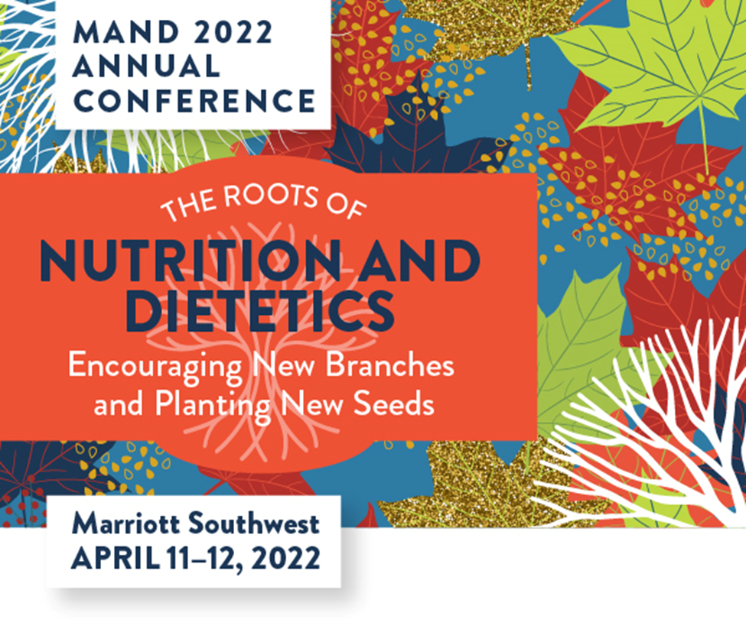

CONFERENCE PROGRAM

AGENDA-AT-A-GLANCE

MONDAY, APRIL 11th
7:00 – 7:45 am Registration & Networking
Continental Breakfast
Exhibits

7:45 – 9:00 am WELCOME
- MAND 2021-2022 Accomplishments
- Recognition of Past Award Winners (2020 & 2021)
- 2022 MAND Award Winners
Alexa Cournoyer, MAND President
Emily Parent, MFCS, RD, LD, FAND, MAND Past President

MONDAY, APRIL 11th

9:00 – 10:00 am KEYNOTE SPEAKER
Delivering Culturally Appropriate Patient Care: Paving the Way to Cultural Humility
Melinda Boyd, DCN, MPH, MHR, RD

This presentation will provide attendees with a better understanding of how to deliver culturally appropriate care to their patients in a variety of practice settings. The focus will be on developing a clinician’s toolbox for culturally appropriate care as a way to foster cultural humility. Understanding how to honor a patient’s culture while delivering evidence-based care is one way to help improve patient outcomes. This presentation will approach this as a method for accounting for differences in race, ethnicity, and religion. At the end of the presentation, attendees will be able to:
1. Identify ways to personally develop cultural humility
2. Understand how to incorporate a patient's cultural beliefs into evidence-based practice
3. Implement culturally appropriate care in their own practice

MONDAY, APRIL 11th

10:00 – 10:30 am BREAK/EXHIBITORS/SPONSORS

MONDAY, APRIL 11th

10:30 – 11:30 am BREAKOUT SESSIONS

THEME:
Thriving Through Gender Transition: What Healthcare Providers Need to Know
Nate Cannon, BA, MFA, CDP

This session will weave educational lecture and personal storytelling to examine the importance of diet, nutrition, and exercise in the lived experience of gender transition. Addressing how hormones influence nutritional needs and the adaptations needed to thrive through gender transition, the session aims to offer resources and knowledge to empower professionals who may work with transgender and gender diverse individuals. Participants will be able to:

1. Discuss how hormone therapy can influence dietary needs in transgender individuals.
2. Identify health related risks of hormone therapy among transgender individuals.
3. Describe best practices for working with transgender individuals in healthcare settings.
MONDAY, APRIL 11th

10:30 – 11:30 am BREAKOUT SESSIONS

CLINICAL:
Mental Health Stigma in Nutrition Care: Moving Beyond Your Biases
Nina Current, MS, RD, LD

Learn about personal bias and how that informs the care you provide to patients with disclosed or non-disclosed mental illness and discover ways to move beyond your bias to provide inclusive nutrition care. Participants will be able to:

1. Understand how stigma affects care for patients with mental illness.
2. Discover where your own biases lie related to mental illness.
3. Apply strategies for working through your biases to provide more inclusive care.

MONDAY, APRIL 11th

10:30 – 11:30 am BREAKOUT SESSIONS

LEADERSHIP:
Paving the Way of the RDN Within a Company
Anna Gustafson, RDN

In this presentation, we will explore the possibilities for roles dietitians can play in a corporation rather than a traditional setting such as clinical, food service, retail, or even corporate wellness. We will discuss the strengths dietitians can bring to these companies, from nutrition expertise to communication skills. Participants will be able to:

1.Identify at least two other relevant business functions (e.g., sales, marketing,
etc.) they may be able to fill.
2. List three benefits a company may gain by hiring a registered dietitian.
3. Participants will be able to name three benefits and two challenges of
exploring a corporate career as a dietitian.
MONDAY, APRIL 11th

11:30 am – 12:30 pm LUNCH
Sponsored by the Minnesota Pork Board

MONDAY, APRIL 11th

12:30 -1:30 pm BREAKOUT SESSIONS

THEME:
The Impact of Service Delivery during the COVID19 Pandemic: Considerations for PLHIV (People Living with HIV) and Social Determinants of Health
Laura Strait, MS, RD, LD

PLHIV (People Living with HIV) have had a unique experience during the COVID19 pandemic when it comes to prevention, treatment, vaccination, and service delivery. This can be illustrated by the social determinants of health - economic stability, education access and quality, health care access and quality, neighborhood and built environment, and social and
community context. The pandemic has had unprecedented impacts not only on these determinants and the care and service delivery for PLHIV which we will discuss in more detail. Participants will be able to:

- Identify considerations for PLHIV as they pertain to COVID19, regarding COVID19 prevention, infection, vaccination, and service delivery
- Identify the social determinants of health and COVID19's impact on these determinants
- Identify the specific determinants of health that have been most impacted for PLHIV during the pandemic

12:30 -1:30 pm BREAKOUT SESSIONS

CLINICAL:
The Power of Whole Food Sources of Protein Including Pork: Your Performance Depends on It
Sponsored by the Minnesota Pork Board
Renee Korczak, PhD, RDN, CSSD, LD

Protein is an essential nutrient that is required in the diet daily. Unlike carbohydrates, protein is not stored in the body, but is required in optimal amounts to help active muscles with recovery and repair during the post-exercise period. The importance of post-exercise protein feeding for endurance athletes is increasingly being acknowledged in sports nutrition research, due to its role in creating net positive muscle protein balance. Factors such as timing, optimization and personalization of protein feeding should all be taken into consideration when working with

(Continued):

endurance athletes. Recent research advocates for the ingestion of hole food protein sources such as pork as opposed to isolated individual amino acids post-exercise. Whole foods provide a matrix rich in dietary protein as well as key vitamins and minerals that can help to stimulate post-exercise muscle recovery and improve overall diet quality. Participants will:

- Compare and contrast current protein recommendations for the post-exercise recovery period
- Identify common sources of plant and animal sources of protein used by athletes for post-exercise recovery
- Discuss recent research trends regarding the standard of practice for use of individual amino acids vs. whole food protein sources

12:30 -1:30 pm BREAKOUT SESSIONS

LEADERSHIP:
Negotiation in Dietetics: Lived Experiences, Success Stories of Dietitians, and an Approach to Advance Skills and Confidence
Suzi Hinck, MS, RDN, LD

This session is an overview of the Leadership Institute from the perspective of a participant. The speaker will present the first research study to be done on lived experiences regarding salary and benefits negotiation within the field of dietetics. The session will conclude by providing the foundation for future efforts of training on negotiation for dietitians. Participants will be:

- Introduced to the Academy of Nutrition and Dietetics’ inaugural Leadership Institute
- Learning about the first study completed on the lived experiences of dietitians regarding salary and benefits negotiation
- Gaining insight on the foundation for future efforts of training on negotiation for dietitians

1:35 – 2:35 pm BREAKOUT SESSIONS

THEME:
Motivational Interviewing For Successful Dietary and Lifestyle Intervention
Riley Larson, MS, RDN, LD

If knowledge alone changed behavior, everyone would eat healthy and dietitians would be out their jobs! When you realize that imparting knowledge and logic alone does not change your client's behaviors, you might feel stuck in your practice. Enter motivational interviewing, a tool to help you as a healthcare professional understand your client's wants, needs, and barriers to change. Used correctly, motivational interviewing techniques builds trusting partnerships between you and your client and will help you move them through the stages of change towards better health. If you are curious how to create better relationships and results with your clients faster, this is a session you will not want to miss. Participants will:

- Understand the history of motivational interviewing and the intention behind the practice of this tool.
- Be able to identify the core components of motivational interviewing.
- Practice using basic MI techniques and improve their ability to implement these tools in clinical practice.

1:35 – 2:35 pm BREAKOUT SESSIONS

CLINICAL
Diet and Immunity – How Various Nutrients and Food Constituents Build the Body’s Defense Against COVID
Julie Miller Jones, PhD, CNS, CFS, FIFT, FAACCI, FICC

The COVID-19 pandemic underscores the need to revisit diet and understand its role in promoting immunity. It is well known that ‘best offense is a good defense.” Diets such as USDA MyPlate, the DASH or Mediterranean Diet balance all the food groups and are associated with decreased risk of both chronic and infective diseases. These diets provide templates for including key nutrients known to promote overall health and strengthen immunity. This talk will briefly review immunology basics and show how specific nutrients facilitate immune cell differentiation, bolster vaccine effectiveness, and participate in reactions needed for both innate and acquired immunity.

(Continued):

Current literature will be presented on the immune functions of vitamins A, Bs, C, D, E, and K; iron, zinc, magnesium, and selenium; and antioxidants and other immune-boosting components present in various foods or added through enrichment and fortification. The impact of polyunsaturated fatty acids, prebiotics and dietary fibers and their metabolites such as short-chain fatty acids in strengthening the immune system will be outlined. Inadequate intake or utilization of various nutrients and important food constituents by vulnerable groups may exacerbate health disparities and increase their COVID risk. Participants will be able to:

- Identify at least three nutrients or food constituents critical to immune functioning and be able to provide suggestions for incorporating key food sources that will provide these components
- List at least one subgroup at high risk for COVID and identify potential low intakes or decreased utilization of nutrients that increase risks for this subgroup
- Name at least one immunity- building nutrient (nutraceutical) contributed by each of the four food groups. Further, the information could be used to convince a client that the omission of a particular food group could impair optimal immunity

1:35 – 2:35 pm BREAKOUT SESSIONS

LEADERSHIP
Current Public Policy Issues in the Nutrition Profession
Rebecca Leighton, MPH, RD and Angelica Anderson, MS, RDN

Public policy impacts all RDs and DTRs - from determining reimbursement rates in clinical nutrition to food access in schools, it is up to us to advocate for our needs. Participants of this session will be invited to learn about and discuss current policy issues relevant to the nutrition profession. Through discussions led by Minnesota policy leaders, you will better understand current legislation impacting the profession and feel empowered to take action. Participants will:

1. Learn about current policy issues impacting nutrition and dietetics
2. Feel empowered to advocate for issues that matter and affect both work and personal lives
3. Feel prepared to meet with legislators and advocate for current policy issues

2:40 – 3:40 pm BREAKOUT SESSIONS

THEME:
The impact of COVID on Eating Disorders – What, Why and What Can Be Done
Hilmar Wagner, MPH, RDN, LN

The COVID Pandemic has been particularly hard on those with mental health issues, especially those with eating disorders. The effects of food scarcity, isolation and increased intake of social media have all combined to create unprecedented demand for specialized treatment. In this session we will explore the reasons why the pandemic has been so devastating for this population and how dietitians in all practice areas can assess for, recognize, and support individuals with disordered eating and eating disorder behaviors. Participants will be able to:

- Summarize factors that contributed to the increase in ED diagnosis and demand for treatment during the pandemic
- Apply effective treatment approaches to use with clients with DE/ED
- Distinguish three indicators that an individual with ED needs referral to specialized care

2:40 – 3:40 pm BREAKOUT SESSIONS

CLINICAL:
Using Continuous Glucose Monitoring to Make Personalized Nutrition Recommendations for People with Diabetes
Laura Russell, MA, RDN, LD, CDCES

Learn how technology is allowing for advanced medical nutrition therapy recommendations for people with diabetes. We will also discuss CGM options, reimbursement and how to start a CGM program. Participants will be able to:

- Cite types of CGM options available to patients
- Use case studies to make nutrition recommendations using CGM data
- Learn how to start a CGM program in their practice

2:40 – 3:40 pm BREAKOUT SESSIONS

LEADERSHIP:
Salary Negotiation for Nutrition and Dietetics Professionals
Meredith Wagner, PhD, RDN, LRD

The ability to negotiate salary is a key skill needed to support nutrition and dietetics professionals as they seek out and obtain employment to ensure they are appropriately compensated for the value they add to the employer. Repeatedly, data indicate that nutrition and dietetics professionals are not being appropriately compensated, likely due to them lacking negotiation skills. Attendees will learn five key principles involved in salary negotiations and be provided with credible resources to reference as they prepare for future salary negotiations. Participants will be able to:

- List and define five essential concepts associated with salary negotiation
- Apply principles of salary negotiation to successfully complete a real-world case study
- Identify three evidence-based resources focused on salary negotiation

3:40 – 4:10 pm BREAK/EXHIBITORS/SPONSORS

MONDAY, APRIL 11th

4:10 – 5:10 pm KEYNOTE SPEAKER
How Does a Pandemic Affect Food Supply? What Are Lessons Learned?
Sponsored by the National Pork Board
Melinda Boyd, DCN, MPH, MHR, RD
The presentation will review the meat supply chain, COVID-19’s impact on the meat industry, and the enhanced practices employed to assure safe food. For this presentation, pork production will be used to illustrate how the overall meat industry operates. For insights on animal care, this presentation will feature a live virtual tour of a barn housing piglets. Participants will be able to:

- Recognize current consumer food safety concerns and explain the impact of COVID-19 on the US meat supply chain
- Explore how today’s pork fits into a sustainable food system through continuous improvement in environmental stewardship, science-based practices promoting animal health and responsible antibiotic use
- Understand emerging trends in agriculture that are helping improve sustainable farming practices and how those trends have helped pig farmers reduce pork’s impact on the environment in terms of land, water, and energy use

MONDAY, APRIL 11th

5:15 – 7:00 pm HAPPY HOUR

Join us for fun, networking and the MAND Foundation Raffle! Hors d’oeuvres and Host Bar.
Raffle drawing at 6:30 pm. Must be present to win a Raffle Gift Basket (need not be
Present to win the Trip for Two to New Mexico).

TUESDAY, APRIL 12th
7:45 – 8:30 am Registration & Networking
Continental Breakfast
Exhibits

TUESDAY. APRIL 12th

8:30 – 10:00 am KEYNOTE SPEAKER
Eating for the Planet: RDN's as Sustainability Champions
Mary Purdy, MS, RDN

With the growing concerns around climate change, the role that the RDN can play in promoting a more sustainable and regenerative food system is as important as ever. This presentation will outline the impacts of our current food system on the environment from production to consumption, highlight programs working towards effective advances, & provide ways dietitians can make a difference in their workplace as well as on a policy level. Participants will walk away with big picture concepts, resources for further education & practical tools that will support a sustainable, resilient, and equitable food system to improve both planetary & human health. Participants will be able to:

1. Identify three ways the current industrial food and agricultural systems negatively impact both human and environmental health and contribute to climate change
2. Describe three ways that a more sustainable food system can better support both planetary and human health and help to mitigate climate change
3. Implement three sustainability strategies to help institutions/organizations or individuals reduce their carbon footprint or “foodprint" and support environmental human health.

TUESDAY, APRIL 12th

10:00 – 10:30 am BREAK/EXHIBITORS/SPONSORS

TUESDAY. APRIL 12th

10:30 – 12 Noon KEYNOTE SPEAKER
Are Pediatric Obesity Prevention Programs & Curriculum Harming Children? Providing Compassionate Trauma-Informed Care, Free From Harmful Stigma to Improve Health Outcomes
Alison St. Germain, MS, RD, LD

Improving health outcomes does not start with preventing childhood “obesity.” In fact, focusing on weight can cause harm. Therefore, health outcomes will not be improved. “Obesity” is multifaceted and a symptom of a complex issue. This presentation will review and evaluate the outcomes on using weight centric versus health centric approaches; review the harm that can be caused using “obesity” as the problem, and the weight stigma it creates; explore the role that determinants of health have on weight and chronic disease. Finally, what can parents and health care professionals do to empower children and to improve their health outcomes? Participants will be able to:
(Continued):

- Explore how using an obesity lens clouds vision, causes harm and is ineffective at “preventing obesity” and improving health outcomes
- Describe trauma informed care and why all healthcare professionals should practice under this lens
- Discover resources to practice weight inclusive, trauma informed care in pediatrics

TUESDAY. APRIL 12th

12:00 Noon – 12:15 pm CLOSING REMARKS

