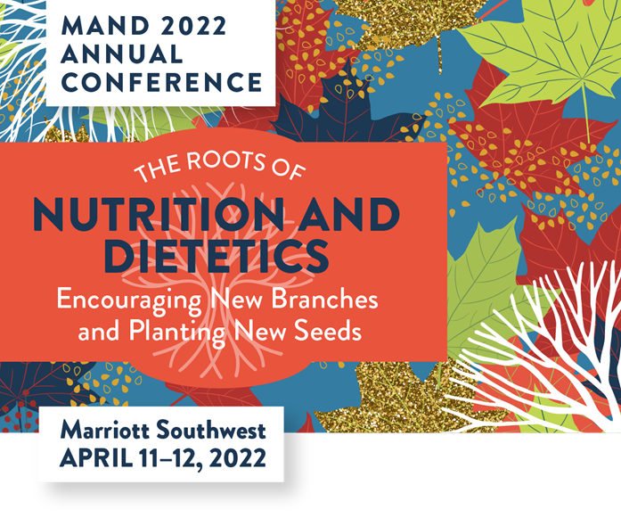

AGENDA AT A GLANCE

Monday, April 11th
7:00-7:45 AM | Registration & Networking  Continental Breakfast  Exhibits
7:45-9:00 AM | Welcome  President’s Business Presentation  Awards
9:00-10:00 AM  1 CPEU | Keynote Speaker  Melinda Boyd, DCN, MPH, MHR, RD - “Delivering Culturally Appropriate Patient Care: Paving the Way to Cultural Humility”
10:00-10:30 AM | Break / Exhibits / Posters
10:30 AM-11:30 AM  1 CPEU each | Breakout Sessions  Theme: Nate Cannon, BA, MFA, CDP - “Thriving Through Gender Transition: What Healthcare Providers Need to Know”  Clinical: Nina Current, MS, RD, LD - “Mental Health Stigma in Nutrition Care: Moving Beyond Your Biases”  Leadership: Anna Gustafson, RDN - "Paving the Way of the RDN Within a Company”
11:30 AM-12:30 PM | Lunch / Exhibits / Posters
12:30-1:30 PM  1 CPEU each | Breakout Sessions  Theme: Laura Strait, MS, RD, LD - “The Impact of Service Delivery during the COVID19 Pandemic: Considerations for PLHIV (People Living with HIV) and Social Determinants of Health”  Clinical: Renee Korczak, PhD, RDN, CSSD, LD - “The Power of Whole Food Sources of Protein Including Pork: Your Performance Depends on It”  Leadership: Suzi Hinck, MS, RDN, LD - “Negotiation in Dietetics: Lived Experiences, Success Stories of Dietitians, and an Approach to Advance Skills and Confidence”
1:35-2:35 PM  1 CPEU each | Breakout Sessions  Theme: Riley Larson, MS, RDN, LD - “Motivational Interviewing For Successful Dietary and Lifestyle Intervention”  Clinical: Julie Miller Jones, PhD, CNS, CFS, FIFT, FAACCI, FICC - “Diet and Immunity – How Various Nutrients and Food Constituents Build the Body’s Defense Against COVID ”  Leadership: Rebecca Leighton, MPH, RD and Angelica Anderson, MS, RDN, LD - “Current Public Policy Issues in the Nutrition Profession”
2:40-3:40 PM  1 CPEU each | Breakout Sessions  Theme: Hilmar Wagner, MPH, RDN, LN - “The impact of COVID on Eating Disorders – What, Why and What Can Be Done”  Clinical: Laura Russell, MA, RDN, LD, CDCES - “Using Continuous Glucose Monitoring to Make Personalized Nutrition Recommendations for People with Diabetes”  Leadership: Meredith Wagner, PhD, RDN, LRD - “Salary Negotiation for Nutrition and Dietetics Professionals”
3:40-4:10 PM | Break / Exhibits / Posters
4:10-5:10 PM  1 CPEU | Keynote Session  Peggy Anne Hawkins, DVM and Lori Stevermer, BS - “How Does a Pandemic Affect Food Supply? What Are Lessons Learned?”
5:15-7:00 PM | Happy Hour and Raffle Drawings at 6:15 pm

Tuesday, April 12th
7:45-8:30 AM | Registration & Networking  Continental Breakfast  Exhibits
8:30-10:00 AM  1.5 CPEU | Keynote Speaker  Mary Purdy, MS, RDN - “Eating for the Planet: RDN's as Sustainability Champions”
10:00-10:30 AM | Break / Exhibits / Posters
10:30 AM – 12:00 PM  1.5 CPEU | Keynote Speaker  Alison St. Germain, MS, RD, LD - “Are Pediatric Obesity Prevention Programs & Curriculum Harming Children? Providing Compassionate Trauma-Informed Care, Free From Harmful Stigma to Improve Health Outcomes”
12:00 -12:15 PM | Closing remarks

POSTER SESSIONS: Up to 3.5 CPEU
You may record several posters that relate to the same performance indicator as one event on your Step 2: Activity Log. One half (0.5) CPEU is equivalent to a one-half contact hour (30 minutes). Practitioners Documentation Required: Certificate of Completion or agenda/timing outline.

EXHIBITORS: Up to 3.5 CPEU
You may record several exhibits that relate to the same learning need code as one event on your Step 2: Activity Log. One-half (0.5) CPEU is equivalent to a one-half contact hour (30 minutes). Practitioners Documentation Required: Certificate of Attendance/Completion/materials describing exhibits.

